**Selective Licensing – How to apply for a licence**

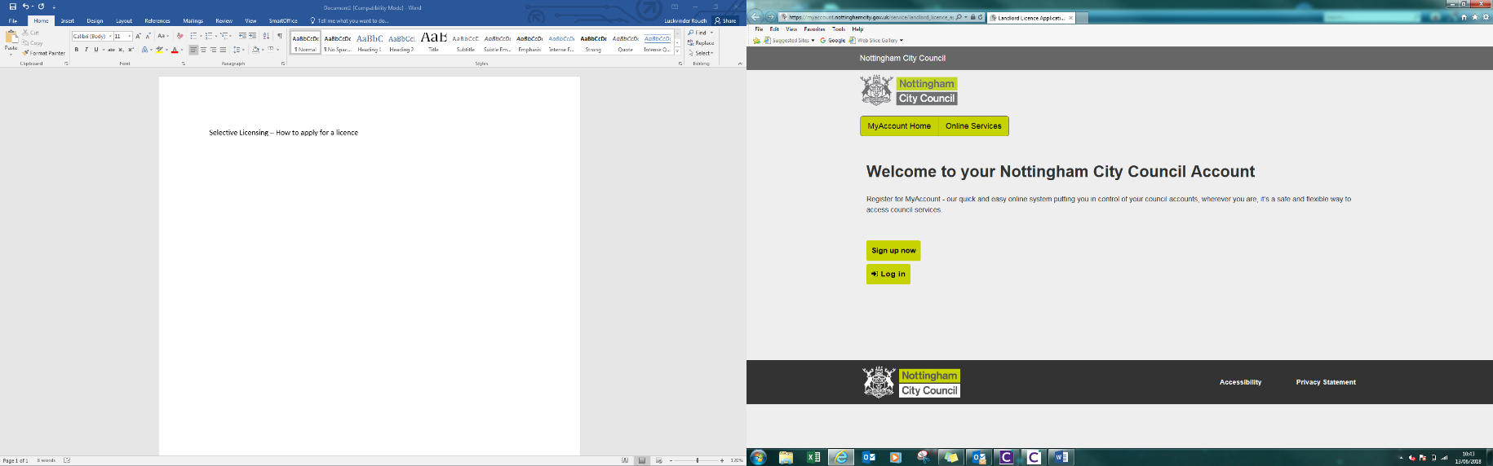Create an account by clicking register. If an account has already been created, please sign in using existing details. The applicant can be anyone in relation to the property E.G. Managing Agent

Please be aware the Applicant is responsible to submit all information for (This includes the licence holder and managers information).

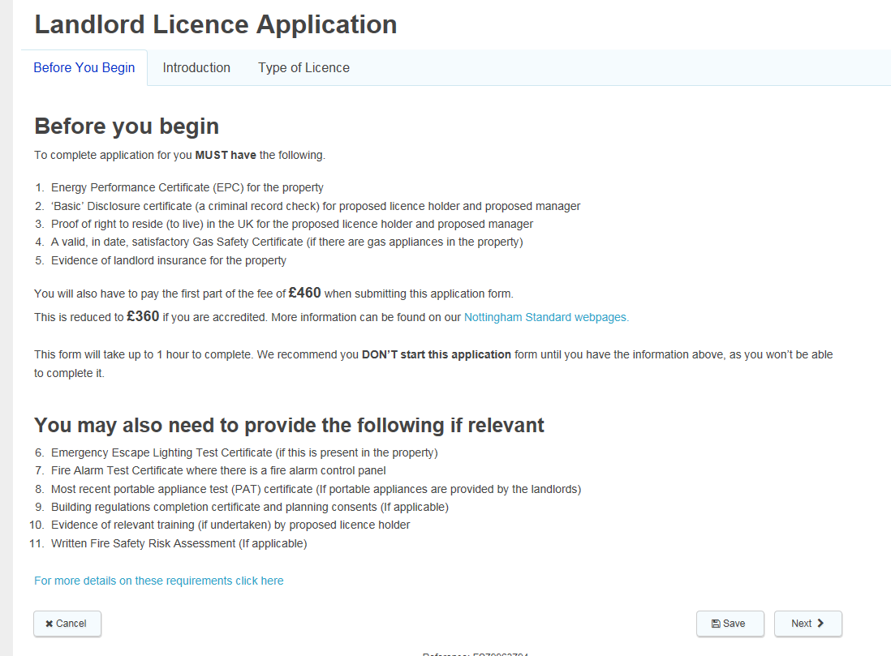**Before you begin**

The ‘Before You Begin’ tab (Circled in red) states all of the required documents you must have to complete a ‘Duly Made’ application. E.G. a current Gas Safety Certificate will be required (If applicable).

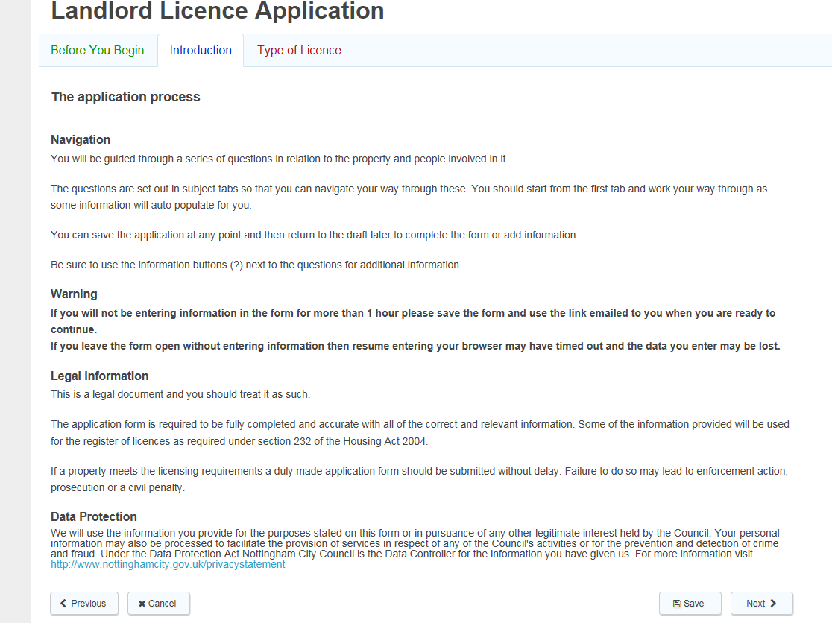**Introduction**

The introduction will go over the any additional information you may need to know regarding the application E.G. ‘**If you will not be entering information in the form for more than 1 hour please save the form’. The introduction** will also advise you that this application is a legal document, please double check the information before submitting the application. If you require additional information, look out for the ‘**?**’.

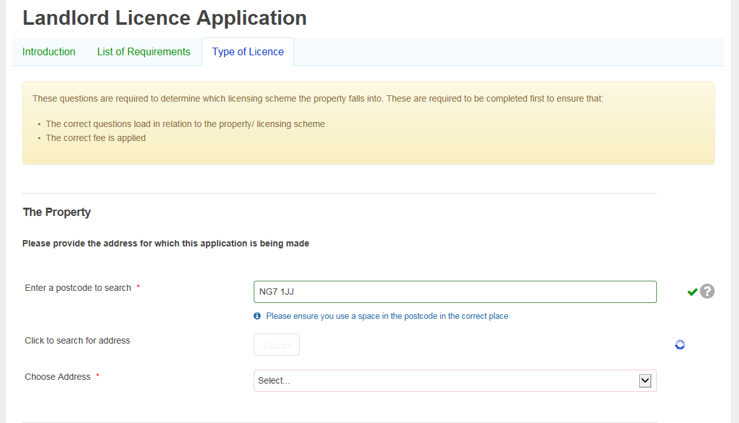**Type of Licence**

Search the property postcode by using the bar. If you require additional information, click on the ‘**?**’ (circled in red). Wait until the blue loading circle (circled in red) has gone, then pick an address from the drop box. If you’re unsure of your postcode please see link below: <http://geoserver.nottinghamcity.gov.uk/myproperty/>

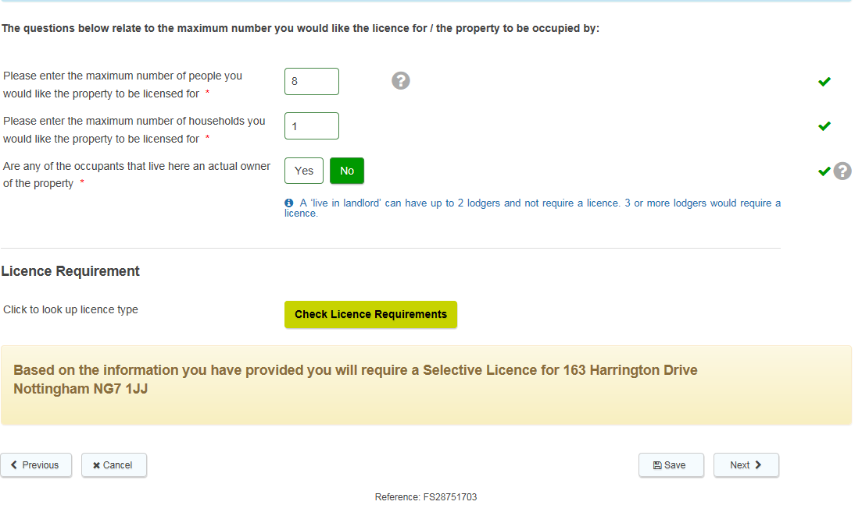Complete the property details E.G. ‘Amount of storeys’. Once all the information regarding the property has been completed. Click on ‘Check Licence Requirements’ to see what licensing scheme your property falls under E.G. Selective Licensing.

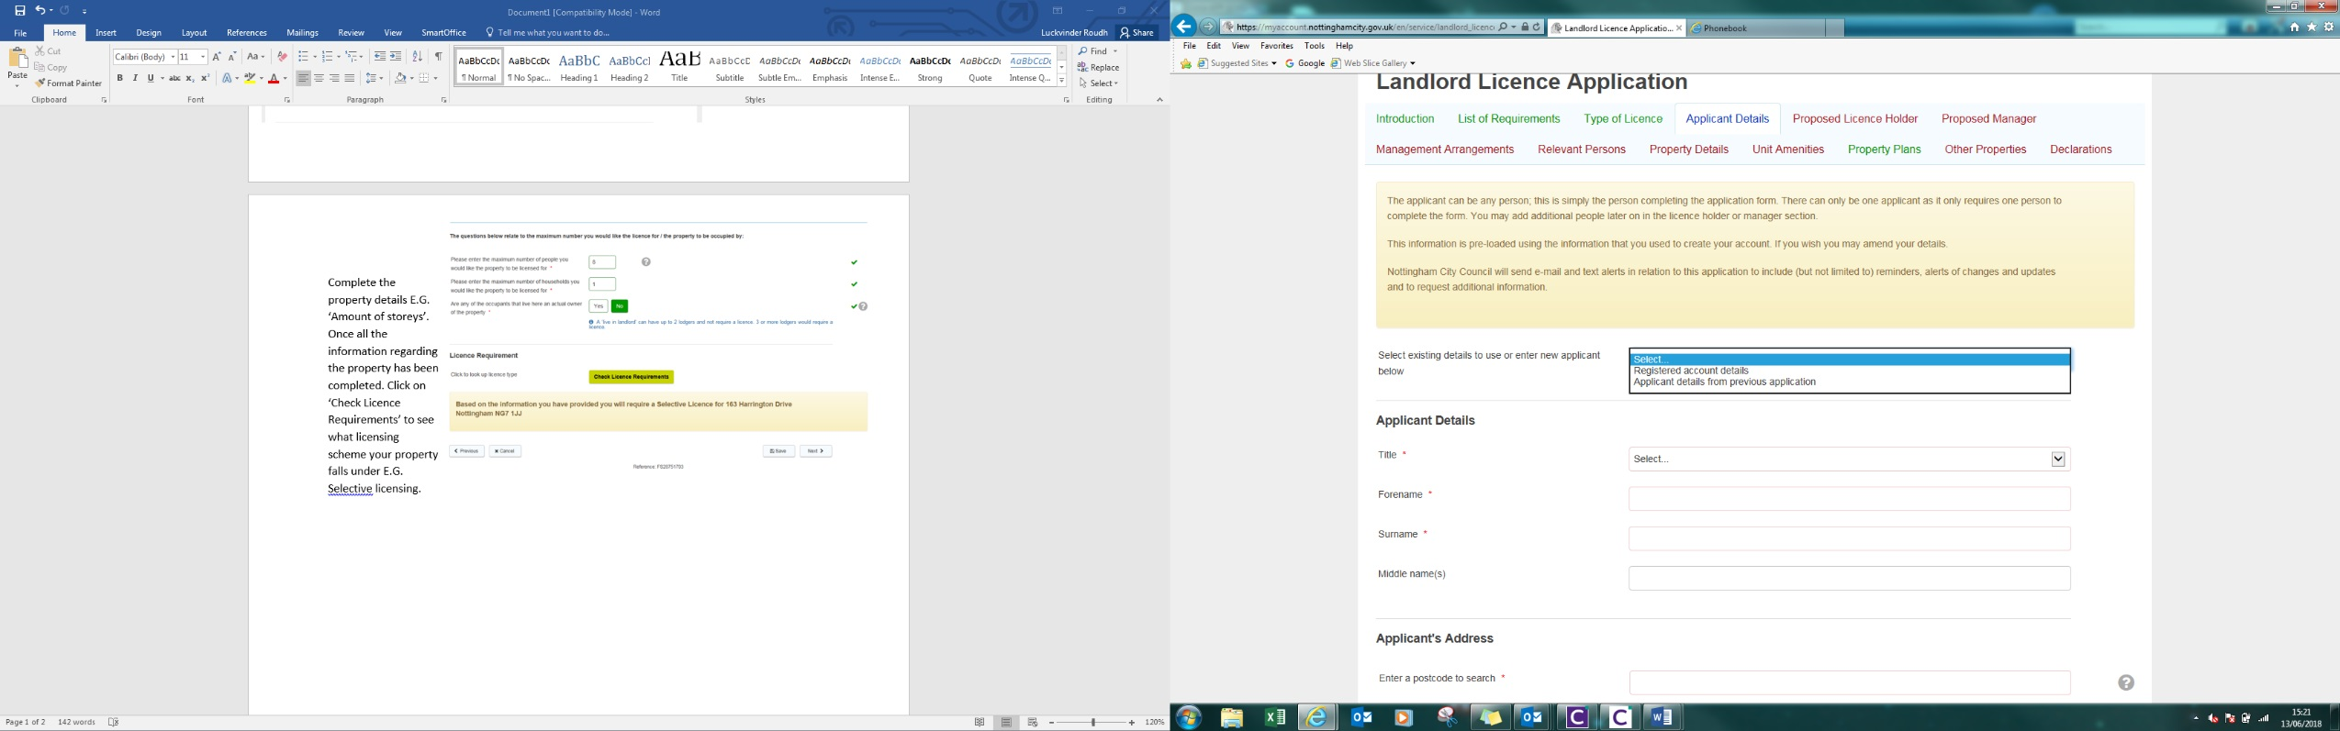**Applicant Details**

Once you are aware of what licence is required, you will need to complete the applicant details. (The applicant will receive all correspondence) You will have the option to choose from the registered account details, or the applicant details from a previous application (If applicable). Please note the * are for mandatory fields (circled in red).

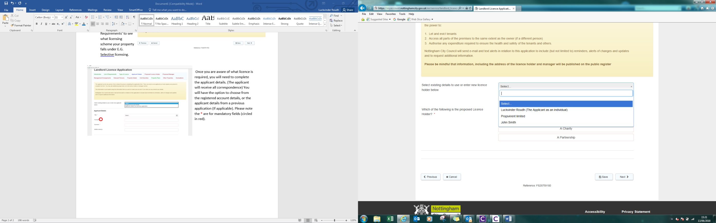**Proposed Licence Holder/Proposed Manager/Managing Arrangements**

When choosing the Licence Holder please keep in mind that ‘The licence holder may be an individual, a company, charity or partnership. You can also have multiple licence holders, for example a husband and wife. The proposed licence holder should normally be the ‘person having control’ of the property.

You will have the option to choose existing details E.G. the applicant or previously entered details.

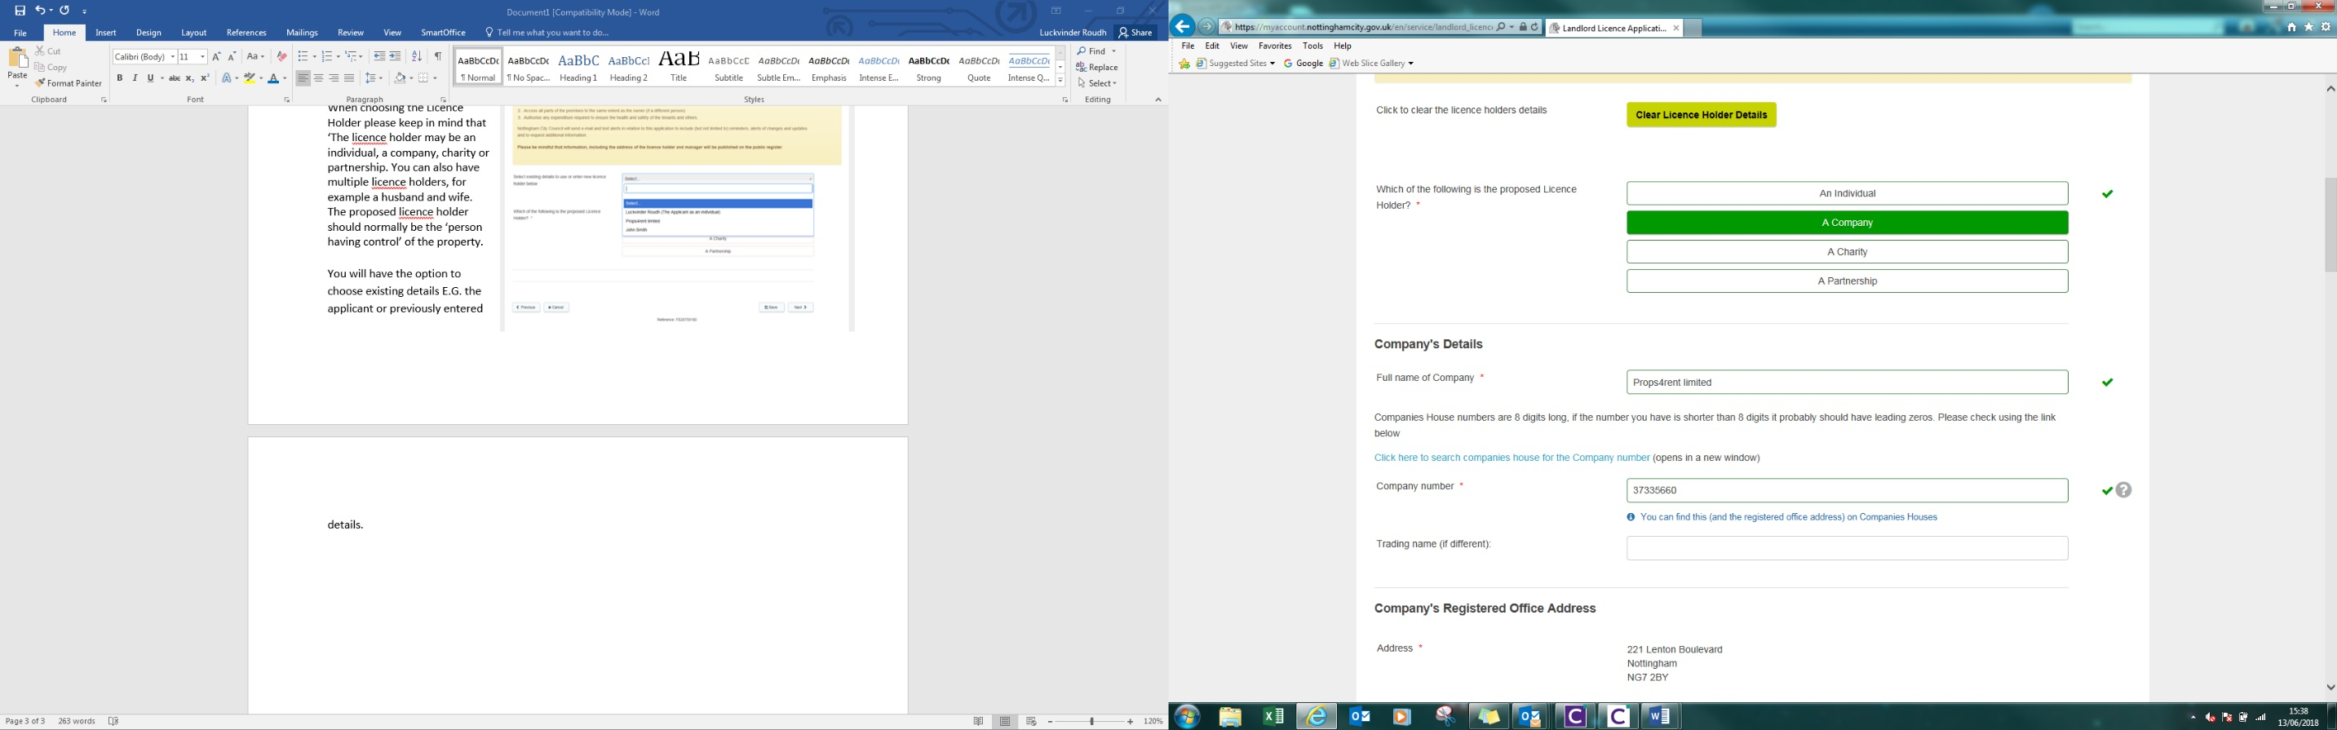

If you have selected a company, you will be required to enter the company number (circled in red). ‘You can find this (and the registered office address) on Companies Houses’ (This is a mandatory field for companies) - Please see link <https://www.gov.uk/get-information-about-a-company>

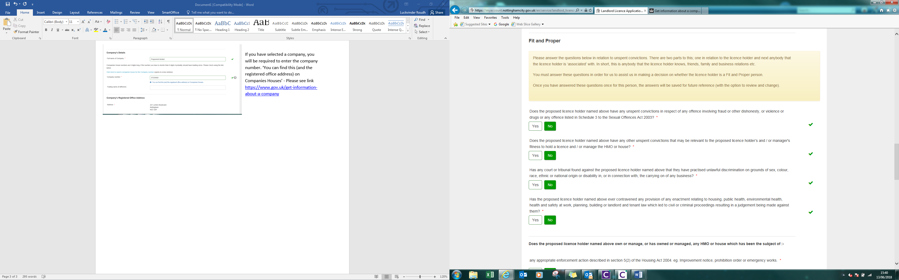

The Licence Holder and Manager (if not the same) will both be required to complete the fit and proper person report. ‘The ‘Fit and Proper’ questions relate to unspent convictions. There are two parts to this; one in relation to the licence holder and next anybody that the licence holder is ‘associated’ with. In short, this is anybody that the licence holder knows, friends, family and business relations etc.’ If you have any previous or pending convictions, please specify the details in the box provided.

Please note: The licence holder will be bound to the licence conditions and be legally responsible for the operation of the HMO or house to be licensed.

The Licence holder must have the power to:

1. Let and evict tenants
2. Access all parts of the premises to the same extent as the owner (if a different person)
3. Authorise any expenditure required to ensure the health and safety of the tenants and others.

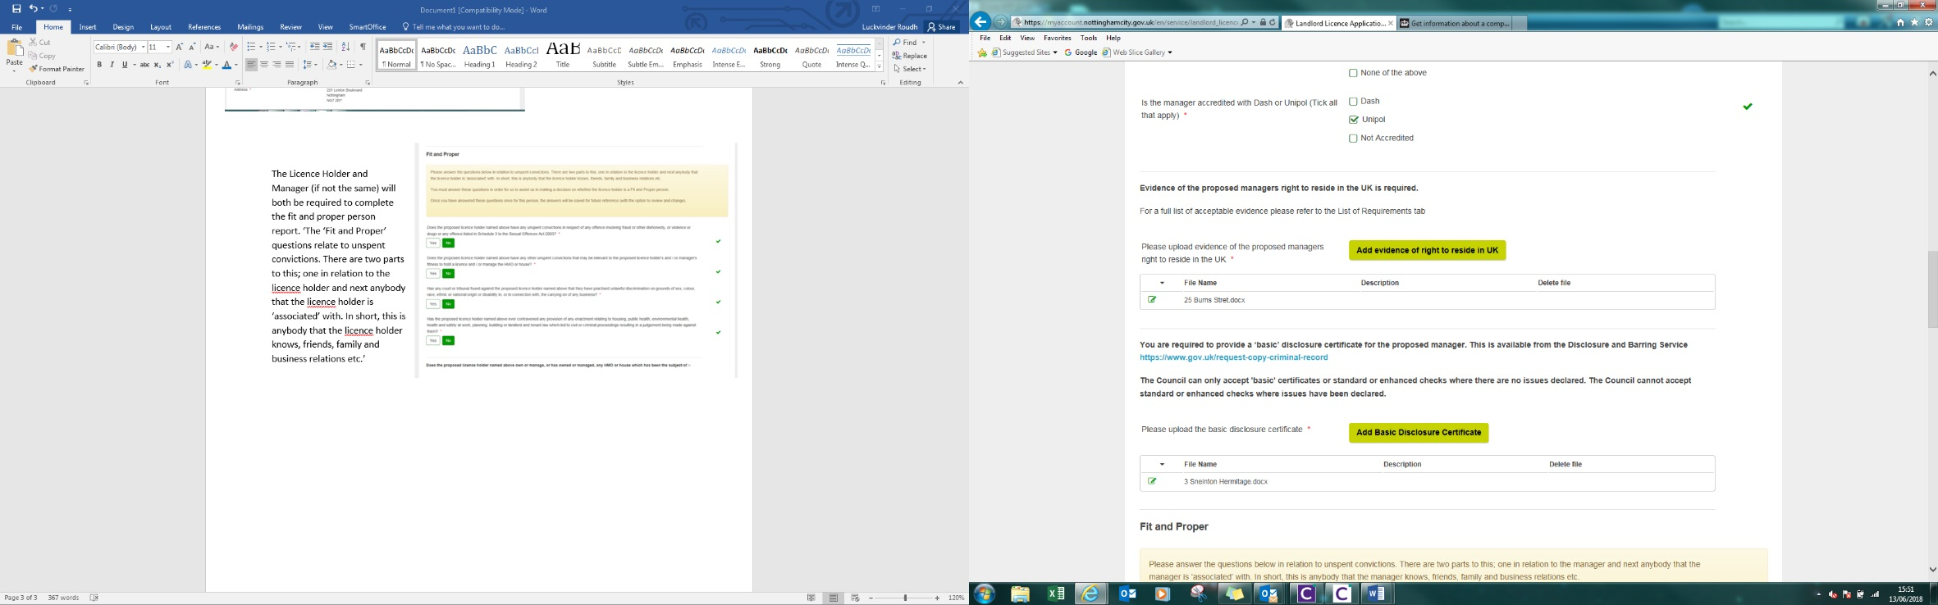

Please be aware that the licence holder and manager will both be requested to submit a current **Basic Disclosure Certificate (DBS).**

How long does a DBS last for? – 3 years, please be aware if your licence is granted, you will be requested to submit a renewed DBS record once it is expired.

What is a DBS? - A basic check is a criminal record check you can request for yourself, or you may be asked to request a basic check by your employer.

How to apply for a DBS? - Please see link <https://www.gov.uk/request-copy-criminal-record>

What would happen if the DBS has criminal activity? The DBS record would still be considered and the application will be passed on to a Licensing officer for further assessment. The outcome will vary depending on the criminal activity. (Please note: The Licence holder and manager must be deemed as ‘Fit and proper’)

**They also need to provide evidence that Licence holder and Manager reside in the UK.What evidence would be required as proof that the Licence Holder and both Manager reside in the UK?**

**List A**

1. A passport showing the holder, or a person named in the passport as the child of the holder, is a British citizen or a citizen of the UK and Colonies having the right of abode in the UK
2. A passport or national identity card showing the holder, or a person named in the passport as the child of the holder, is a national of a European Economic Area country or Switzerland.
3. A Registration Certificate or Document Certifying Permanent Residence issued by the Home Office to a national of a European Economic Area country or Switzerland.
4. A Permanent Residence Card issued by the Home Office to the family member of a national a European Economic Area country or Switzerland.
5. A current Biometric Immigration Document (Biometric Residence Permit) issued by the Home Office to the holder indicating that the person named is allowed to stay indefinitely in the UK, or has no time limit on their stay in the UK.
6. A current passport endorsed to show that the holder is exempt from immigration control, is allowed to stay indefinitely in the UK, has the right of abode in the UK, or has no time limit on their stay in the UK.
7. A current Immigration Status Document issued by the Home Office to the holder with an endorsement indicating that the named person is allowed to stay indefinitely in the UK or has no time limit on their stay in the UK, together with an official document giving the person’s permanent National Insurance number and their name issued by a Government agency or a previous employer.
8. A full birth or adoption certificate issued in the UK which includes the name(s) of at least one of the holder’s parents or adoptive parents, together with an official document giving the person’s permanent National Insurance number and their name issued by a Government agency or a previous employer.
9. A birth or adoption certificate issued in the Channel Islands, the Isle of Man, or Ireland, together with an official document giving the person’s permanent National Insurance number and their name issued by a Government agency or a previous employer.
10. A certificate of registration or naturalisation as a British citizen, together with an official document giving the person’s permanent National Insurance number and their name issued by a Government agency or a previous employer.

**List B**

1. A passport showing the holder, or a person named in the passport as the child of the holder, is a British citizen or a citizen of the UK and Colonies having the right of abode in the UK.
2. A passport or national identity card showing the holder, or a person named.
3. A Registration Certificate or Document Certifying Permanent.
4. A Permanent Residence Card.
5. A current Biometric Immigration Document (Biometric Residence Permit).
6. A current passport endorsed to show that the holder is exempt from immigration control.
7. A current Immigration Status Document. A full birth or adoption certificate.
8. A certificate of registration or naturalisation as a British citizen

[**List B**](https://myaccount.nottinghamcity.gov.uk/fillform/?iframe_id=fillform-frame-1&db_id=#listB)

1. A current passport endorsed to show that the holder is allowed to stay in the UK.A current Biometric Immigration Document (Biometric Residence Permit) issued by the Home Office to the holder which indicates that the named person can currently stay in the UK.
2. A current Residence Card (including an Accession Residence Card or a Derivative Residence Card) issued by the Home Office
3. A current Immigration Status Document containing a photograph issued by the Home Office to the holder with a valid endorsement indicating that the named person may stay in the UK, together with an official document giving the person’s permanent National Insurance number and their name issued by a Government agency or a previous employer.
4. A Certificate of Application issued by the Home Office under regulation 17(3) or 18A (2) of the Immigration (European Economic Area) Regulations 2006, to a family member of a national of a European Economic Area country or Switzerland, together with a Positive Verification Notice from the Home Office Employer Checking Service.
5. An Application Registration Card issued by the Home Office, together with a Positive Verification Notice from the Home Office Employer Checking Service.
6. A Positive Verification Notice issued by the Home Office Employer Checking Service, which indicates that the named person may stay in the UK.

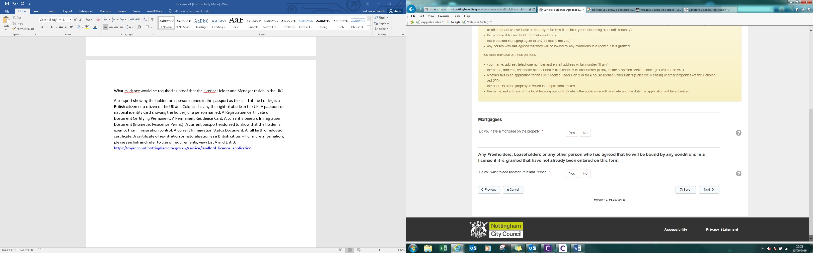

**Relevant Persons**

**Mortgagees**

You will be required to enter the mortgage providers details (if applicable) and any other relevant persons E.G. co-owner.

**Please be mindful that information, including the address of the licence holder and manager will be published on the public register.**

**Please note: If you have any genuine concerns regarding publicising your details on the public register, please contact the Selective licensing team with reason. See contact details below:**

**Email:** [**Selective.licensing@nottinghamcity.gov.uk**](mailto:Selective.licensing@nottinghamcity.gov.uk)

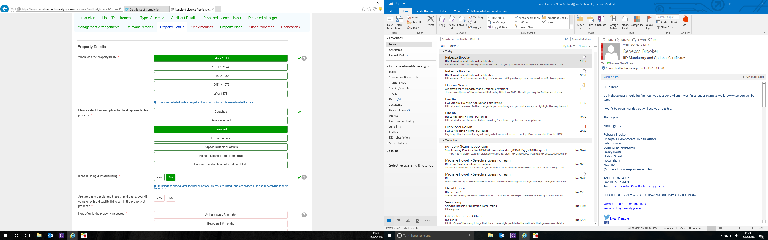**Property Details**

Please select the boxes that are relevant to your property

Buildings of special architectural or historic interest are 'listed', and are graded I, II* and II according to their importance

|  |  |
| --- | --- |
| Detached house | A **detached** houses is a stand-alone |
| Semi-detached | **Semi**-**detached house** is one that is joined to another by a common wall that they share |
| Terrace Housing | **Terraced houses**, also referred to as row housing or town homes |
| End of Terrace | An **end terrace** is a property at the end of a row of more than 2 properties |
| Purpose built flats | **Purpose built flats** are **flats** which have been constructed from the beginning as **flats** rather than **flats** which have been converted |
| Mixed residential and commercial | A '**mixed use**' **property** is one that has both residential and non-residentia**l** elements, eg a flat connected to a shop, office etc. |
| House converted into self-contained flats | A building converted exclusively into self-contained flats. |

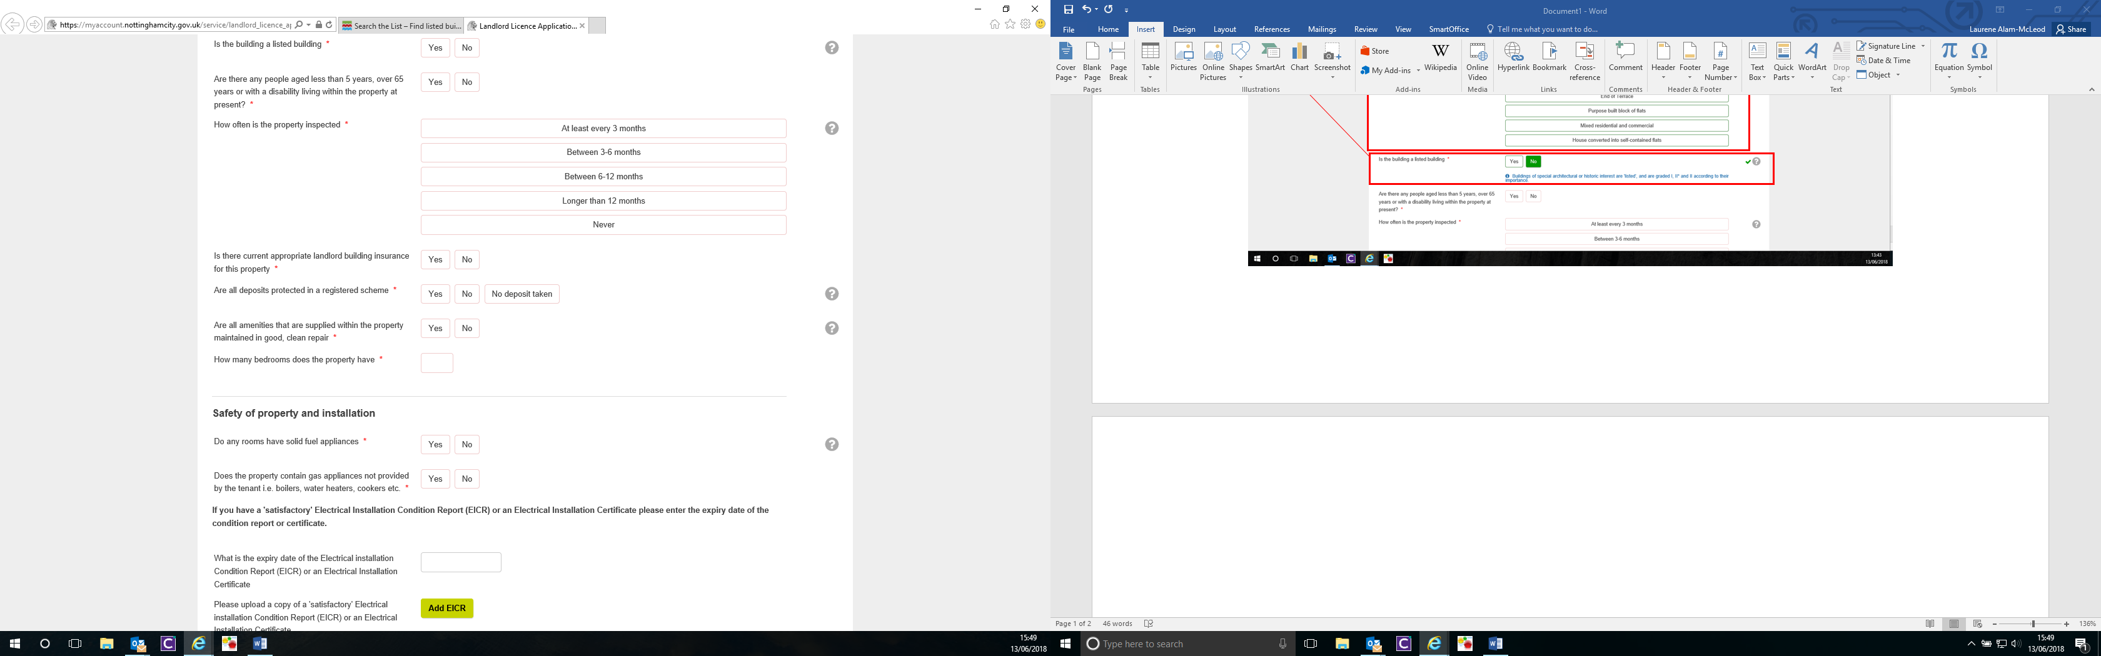This box is required, as we need to assess if any of the tenants are vulnerable. Please select the relevant box

Please select the relevant frequency the property is inspected.

Upon selecting ‘yes’, documented evidence will be required to move forward. You must also state the date. If you select no this will be a condition on your licence

Tenancy deposits are required to be registered with a tenancy deposit scheme.

More information can be found on the government website. [Ihttps://www.gov.uk/tenancy-deposit-protection](https://www.gov.uk/tenancy-deposit-protection)

As part of the selective licensing requirements, you will asked to submit a copy of your PAT certificate, if your provide any portable applications.

In relation to obtaining a PAT certificate:

You **do not** need a qualified electrician to carry out your PAT Testing, **you do** however need a competent person who understands how **t**o carry out a full visual inspection

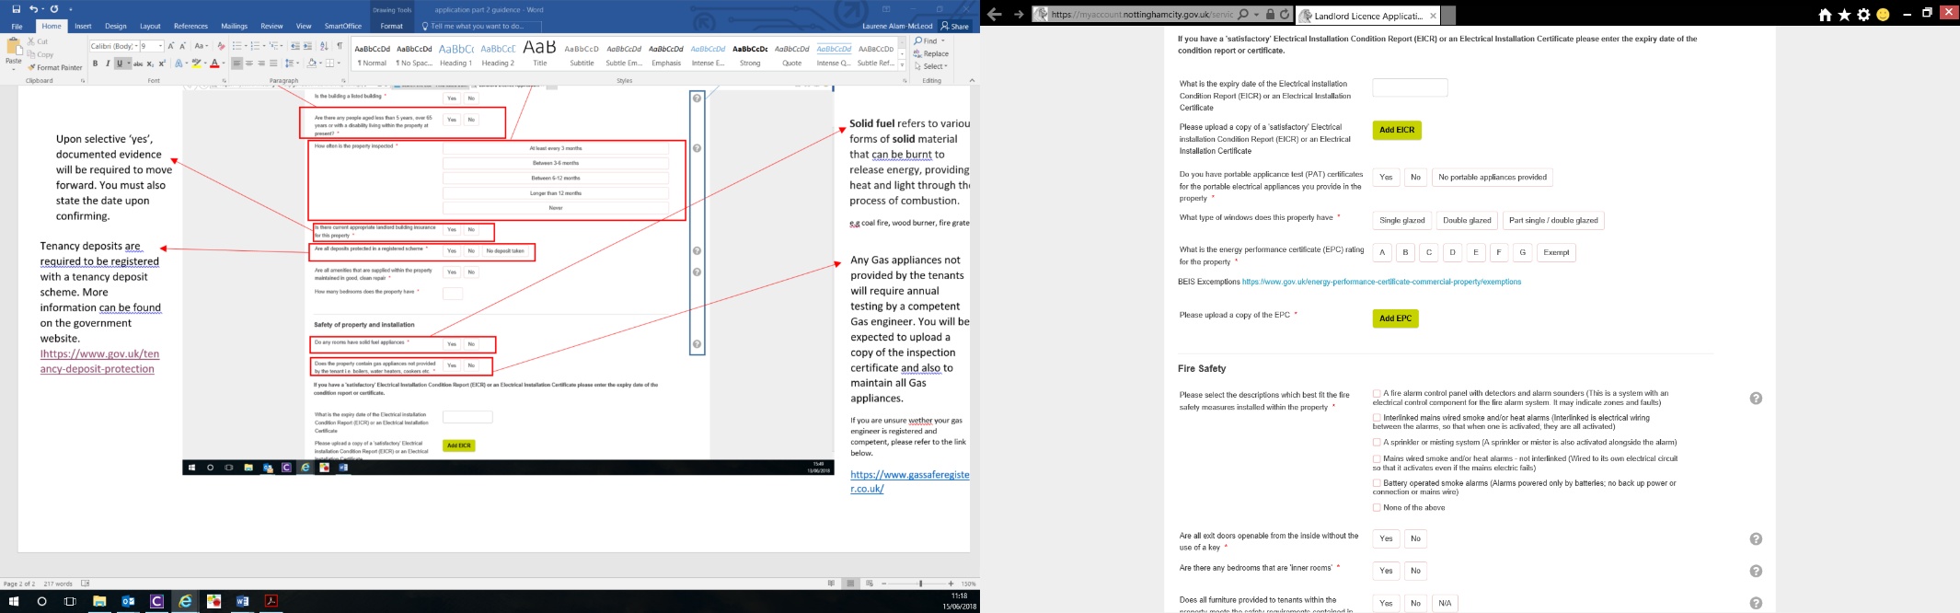

Your EICR is a non-mandatory field.

Please enter the expiry date and submit a copy of the **full, clear and current** copy of the EICR.

A copy of your EPC is required at this stage.

If your property is exempt you will need to tell us on what grounds (such as it is a listed building)

You will need to state the grade and provide a full, clear and current copy.

Select the relevant system that has been installed. If you have ‘a fire alarm control panel with detectors and alarm sounders’ you will be asked to submit your relevant certificate.

Other systems may also require contractor details.

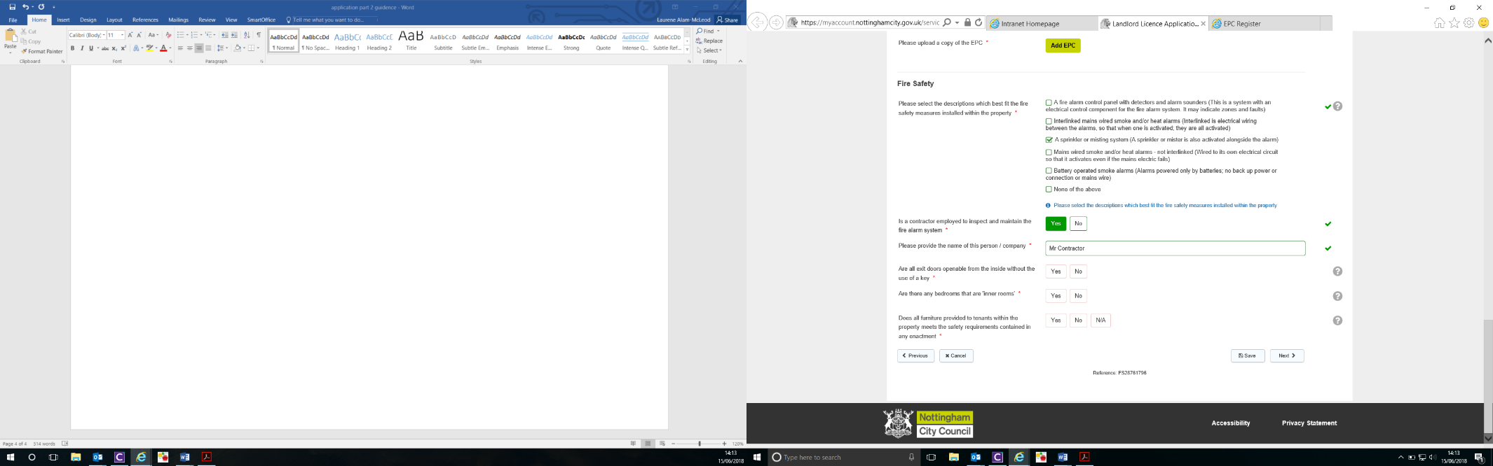An Inner Room is defined as:

A room from which escape is possible only by passing through another room.

This information is required an officers may asses any difficulties a tenant may have trying to escape during a fire.

If you unsure whether or not the provided furniture meets requirements, please refer to:<https://www.firesafe.org.uk/furniture-and-furnishings-fire-safety-regulations-19881989-and-1993/>

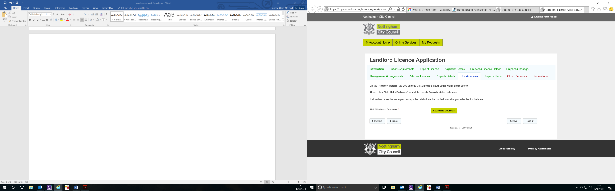**Unit Amenities**

Enter the details of each room (Name of unit e.g Bedroom1, Bedroom2 etc.). Include how many people may occupy the room and the room size.

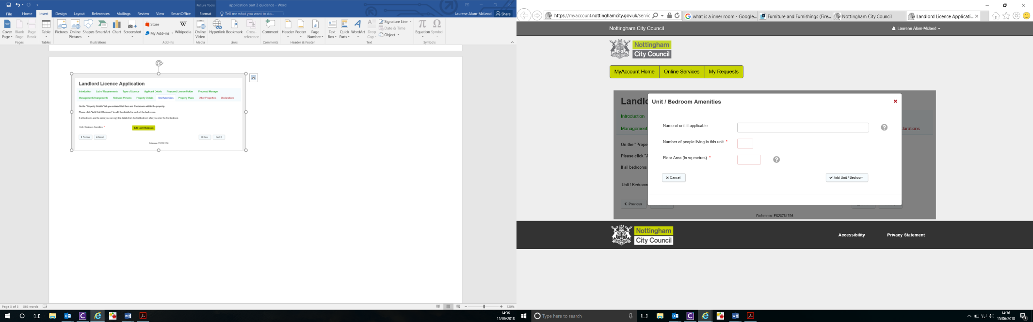Include all bedroom room/units and their sizes accurately, as this information should correspond with the sketch plans that could be submitted later in the application process

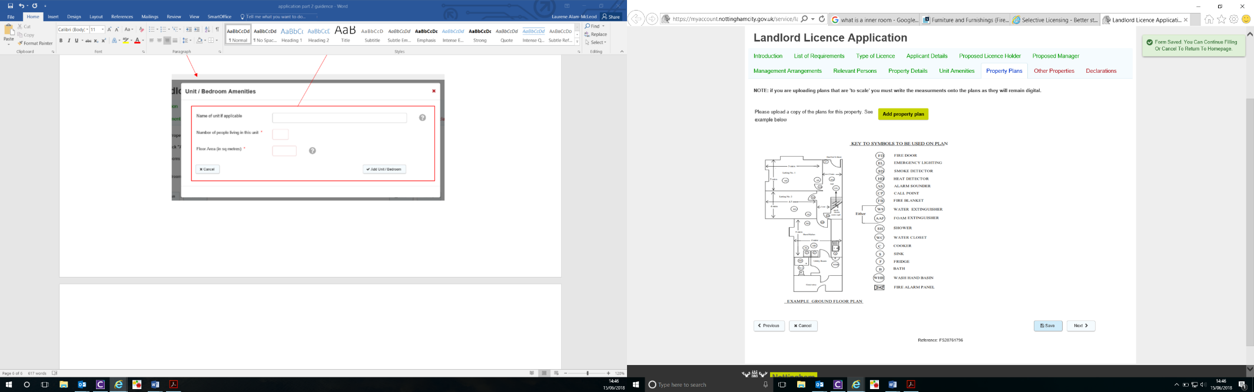

**Property Plans**

If you have them, upload your sketch plans:

Plans should be of the full property/unit the application is in reference to and complete with amenity details and measurements.

Please refer to the example provided on the application page for guidance.

You may upload more than one attachment if your plans are over several pages or are in several documents.

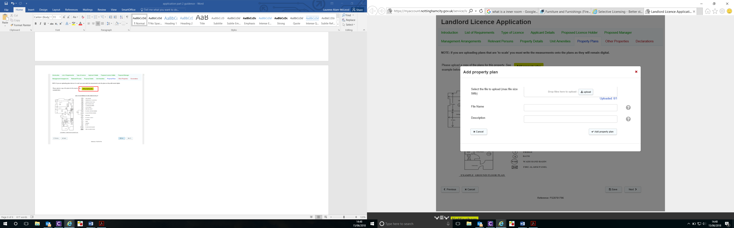

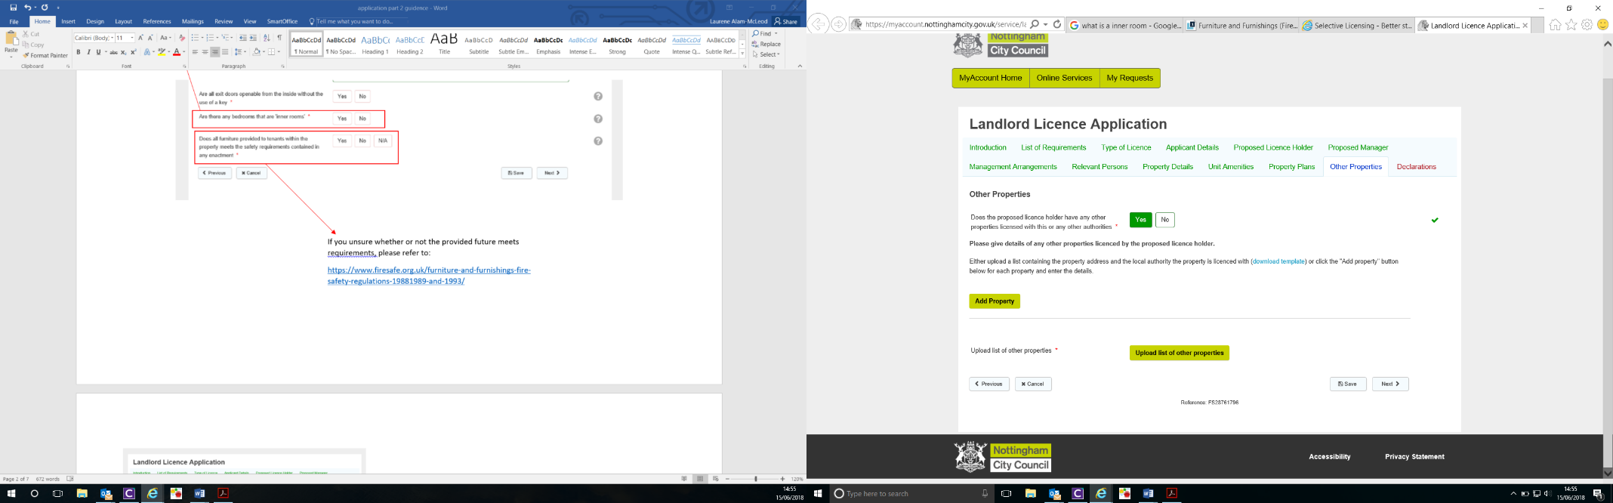**Other Properties**

Manually enter the property address and the local authority the property is licenced under

If you already have a list saved of all your licenced property, including the local housing authority they are licenced under, you may attach them under this tab

**Declarations**

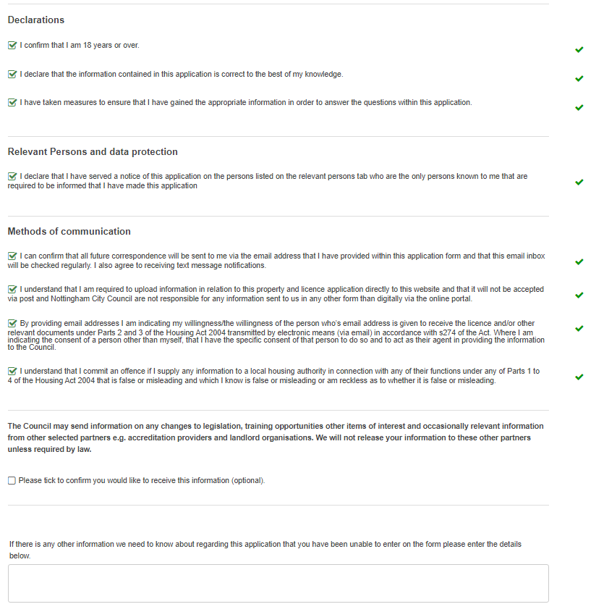Please tick all declarations and methods of communications.

The last section is optional

You may also enter any further details in this box

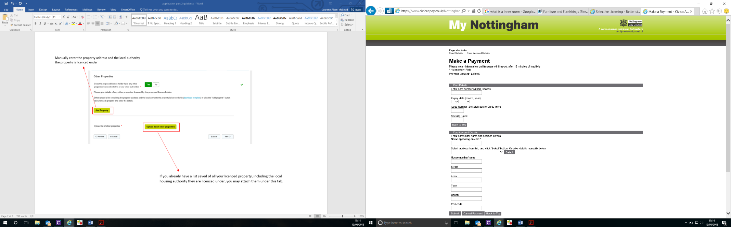**Payment Stage**

Complete the payment page, clicking ‘**submit**’ once all details are complete.

Upon submitting, you may be required to submit a further time confirming your details and the application pricing.

